Home Automation with Firewall

Suhail Khan 17101A0074  
 Nikhil Dhangada 15101A0047  
 Aakash Mahadik 19101A0011

Department of T. E. (Information Technology), University of Mumbai

Vidyalankar Institute of Technology Wadala(E),

Mumbai 400 037

Abstract— Home Automation is a iOT based project aimed towards securing your private network responsible for all your automations. To secure the network we use IDS technology of firewall and is currently able to detect attacks such as DoS.

The IDS uses ML based SVM algorithms which has already been feed with a huge dataset of TCP, UDP and ICMP dumps. Dataset was also created by us and every time system detects attack it stores new records and trains itself to block more sophisticated attacks.

We also implemented a PiR Motion detector system with our relay board and ESP 8266 module which gives out alert when a person passes within a certain distance

1. Introduction

The fundamental purpose of monitoring electronics appliances in the modern world by using Internet of Things (IoT) is to control them based on situational demands. With the advancement of technology, the need for efficient controlling is more as it optimizes performance and saves unnecessary wastage of power. The basic home appliances are fan, light and water pump which consume maximum power. Unnecessary wastage of power and resources by turning on lights during daytime or high-speed fans in winter season or water pump during overflow of water from tank can be avoided in this way. A system has been proposed to control home appliances anytime from anywhere in the world and efficiently utilize power by controlling appliances properly. Blynk app has been used to read data from sensors located in home environment and user controls home appliances based on these data. Being busy in hectic schedule of daily life user may not be able to read sensor data continuously to take some action through app. So, the designed system sends an emergency notification in user’s mobile app

III. LITERATURE SURVEY Kumar Mandula [2] discusses about the process of home automation using Bluetooth and Ethernet. When connectivity between Arduino and smart phone is established using Bluetooth, short range wireless communication is possible in an indoor environment. Ethernet module is used for connecting Arduino board from any part of the world. Bharat Bohora[3] designeda system based on Blynk framework which controlled and monitored appliances via smartphone by using Wi-Fi as communication protocol and raspberry pi as private server. All the appliances and sensors are connected to the internet via NodeMCU. Ming Wang[4] in his paper discussed about his work on system that uses a smart central controller to set up a 433 MHz wireless sensor and actuator network (WSAN). A series of control modules, such as switch modules, radio frequency control modules, have been developed in the WSAN to control directly all kinds of home appliances. P.Siva Nagendra Reddy [5] used android mobile to send commands to the Arduino board through Wi-Fi module and Arduino processed them to control all the home appliances. This system controlled the voltage levels of home appliances like fan, light etc. They got the status of their home appliances in their android mobile phone. M L Sharma [6] developed a system in which a home automation system was interfaced with Android mobile devices. The mobile device and system communicated with each other via Wi-Fi. Somnath Singh [7] in his paper discussed about designing a web-based control of home appliances which allowed user to switch appliances on/off by clicking on a webpage specially designed to interact with those devices, by being anywhere in the world with a computer or a smart phone connected with the Internet. Miss. Aboli Mane [8] used Blynk app in her project of home management system and security. Different sensors were connected with NodeMCU. With the help of Wi-Fi, NodeMCU was connected with Blynk app. On detection of any unwanted incident by different sensors, messages were sent to Blynk app.

IV METHODOLOGY

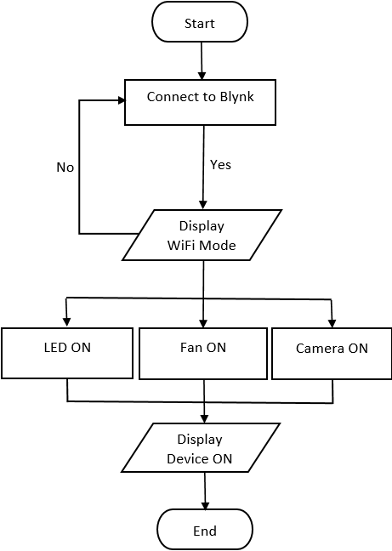

V PROBLEM DEFINITION

The more ways for devices to be able to connect to each other, the more ways threat actors can intercept them. Protocols like HTTP (Hypertext Transfer Protocol) and API are just a few of the channels that IoT devices rely on that hackers can intercept.

The IoT umbrella doesn't strictly include internet-based devices either. Appliances that use Bluetooth technology also count as IoT devices and, therefore, require IoT security. Oversights like this have contributed to the recent spike in IoT-related data breaches.  
Below are a few of the IoT security challenges that continue to threaten the financial safety of both individuals and organizations.  
1. Remote exposure  
2. Lack of industry foresight  
3. Resource constraints

The Project uses Blynk Local server developed in Java which is installed in RaspberryPi and ran throughout. Using local blynk client you can connect to this server by mentioning the ip address of your raspberry pi and port number on which blynk is running By default it should be 9443.

Components:

Hardware:

1.ESP 8266

2.Relay Board

3.Jumper Wires

4.PiR Sensor

5. RaspberryPi

6.PowerSupply

7. LED Bulb and Switch Board

Software:

Blynk: Blynk server is installed in RaspberryPi and stored near router, getting powered via PoE.

ArduinoIDE: To write programs we used Arduino IDE

The designing methodology of the system has two major portions: software design and hardware design. The hardware is designed by arranging microcontroller, sensors, and actuators whereas software design includes programming that is written and uploaded in the microcontroller. The designed system shows microcontroller connected to sensor-modules and actuator-modules for monitoring and controlling household devices. This design section shows how different hardware components are set up. The specifications and information regarding various components are described below .The system is modelled to monitor data from PIR sensor-module and control two loads by using mobile application.

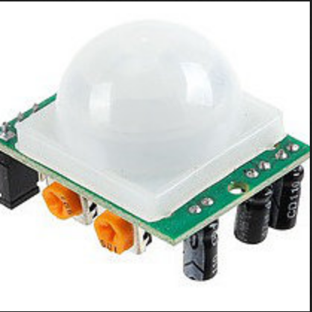

PIR sensors are more complicated than many of the other sensors explained in these tutorials (like photocells, FSRs and tilt switches) because there are multiple variables that affect the sensors input and output

The PIR sensor itself has two slots in it, each slot is made of a special material that is sensitive to IR. The lens used here is not really doing much and so we see that the two slots can 'see' out past some distance (basically the sensitivity of the sensor). When the sensor is idle, both slots detect the same amount of IR, the ambient amount radiated from the room or walls or outdoors. When a warm body like a human or animal passes by, it first intercepts one half of the PIR sensor, which causes a positive differential change between the two halves. When the warm body leaves the sensing area, the reverse happens, whereby the sensor generates a negative differential change. These change pulses are what is detected.

ESP8266  
ESP8266 is a wifi SOC (system on a chip) produced by Espressif Systems . It is an highly integrated chip designed to provide full internet connectivity in a small package.  
ESP8266 can be used as an external Wifi module, using the standard AT Command set Firmware by connecting it to any microcontroller using the serial UART, or directly serve as a Wifi-enabled micro controller, by programming a new firmware using the provided SDK.

The GPIO pins allow Analog and Digital IO, plus PWM, SPI, I2C, etc.

This board has been around for almost a year now, and has been used mostly in IoT contexts, where we want to add connectivity for example to an Arduino project. A wide adoption has been facilitated by the very modest price, ranging from 2.50 to 10 USD depending on the features offered by the manufacturers.

Relay Board

A power relay module is an electrical switch that is operated by an electromagnet. The electromagnet is activated by a separate low-power signal from a micro controller. When activated, the electromagnet pulls to either open or close an electrical circuit.

A simple relay consists of wire coil wrapped around a soft iron core, or solenoid, an iron yoke that delivers a low reluctance path for magnetic flux, a movable iron armature and one or more sets of contacts. The movable armature is hinged to the yoke and linked to one or more set of the moving contacts. Held in place by a spring, the armature leaves a gap in the magnetic circuit when the relay is de-energized. While in this position, one of the two sets of contacts is closed while the other set remains open.

When electrical current is passed through a coil, it generates a magnetic field that in turn activates the armature. This movement of the movable contacts makes or breaks a connection with the fixed contact. When the relay is de-energized, the sets of contacts that were closed, open and breaks the connection and vice versa if the contacts were open. When switching off the current to the coil, the armature is returned, by force, to its relaxed position. This force is usually provided by a spring, but gravity can also be used in certain applications. Most power relays are manufactured to operate in a quick manner.

Flow Chart

RESULT :---

The Blynk application provides the facility to read sensor data and control appliances easily. For two appliances using 2 channel relay and controlling it using Blynk Client via switch and having a gauge for reading sensor reading. IDS Running in background gives alert when someone tries to perform attack on your server.

CONCLUSION :--

This project is a successful demonstration of how easy it is to safeguard your entire home automation system by just installing a RaspberryPI with some filtration technology (in this case it’s a IDS). Sensor reading is not stable on Gauge Meter on Blynk Client which can be improved and then the Firewall itself which was made by us could be improved a lot.

iOT Security is major issue and to tackle it supervised model might lack some skills compared to unsupervised model which works on clusters so changing the algorithm itself might get reflected soon.

REFERENCES :-

[1] https://einstronic.com/wp-content/uploads/2017/06/NodeMCU-ESP8266-ESP-12E-Catalogue.pdf

[2] https://akizukidenshi.com/download/ds/aosong/DHT11.pdf

[3] ftp://imall.iteadstudio.com/Electronic_Brick/IM120710017/DS_IM120710017.pdf

[4] https://cdn.sparkfun.com/datasheets/Sensors/Proximity/HCSR04.pdf

[5] https://www.blynk.cc/